Race Kings

Submitted by:

1. 1805066
2. 1805063
3. 1805084

Introduction: In order to use igraphics and getting skillful in using it we tried to make a racing game.

Properties:

1. Opening the game a nice menu bar will appear and there will be a nice background image. There will be a box to enter the player name. There will be Play, High score and Quit option.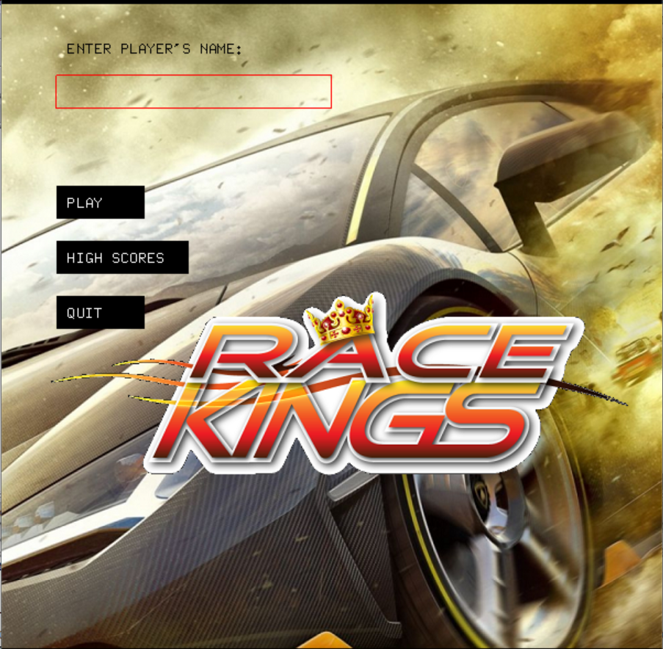
2. By clicking on the play option one can enter in the game where he has to control a car. The objective is to be first in the race.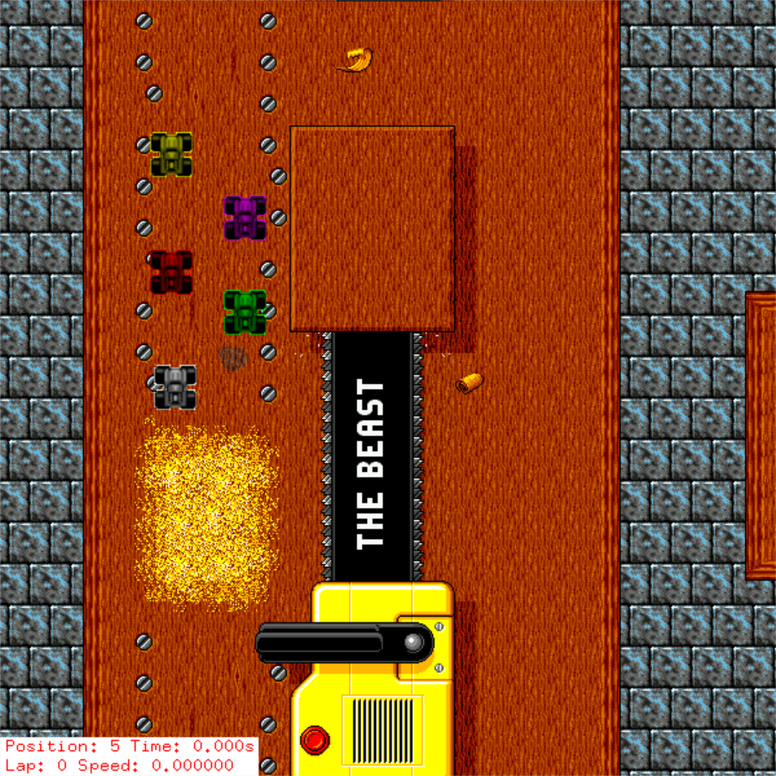
3. In high score we save top 3 best timing.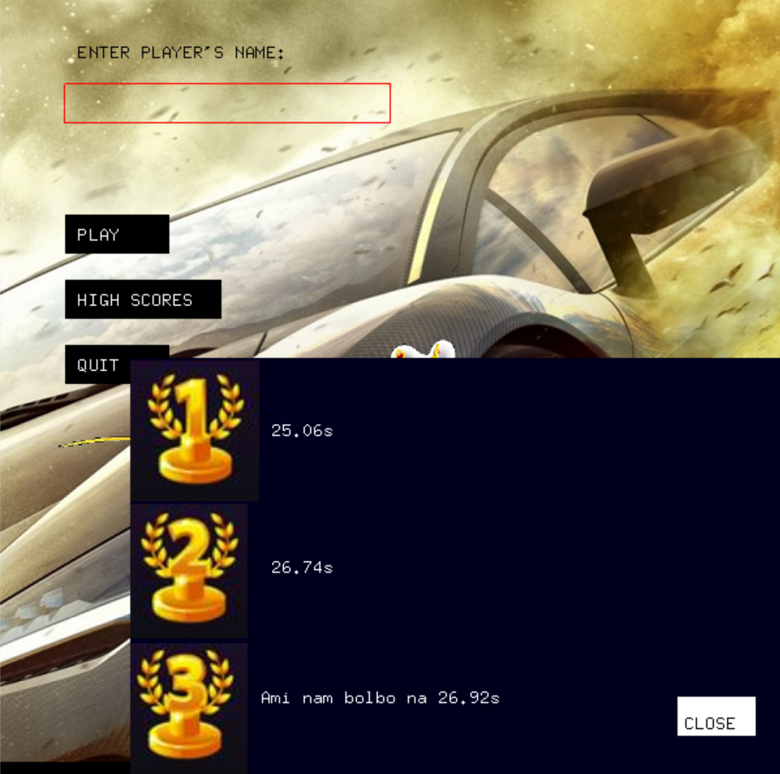
4. We used clock() function to calculate time and divided the race tracks in blocks to calculate player position. 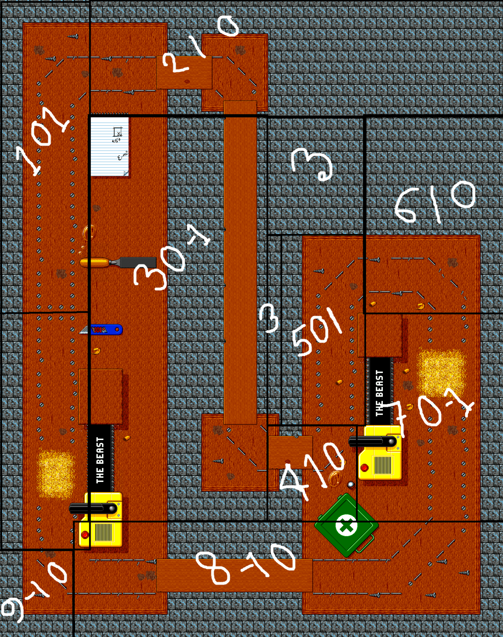In every block there are three numbers. First one is block number. The position of a player will be better if his block number is greater. Next two numbers a, b denote the coefficients of x and y coordinates. If two players stay at same block then (ax+by) value will indicate which player is advanced.
5. We used path creator to create path for opponent.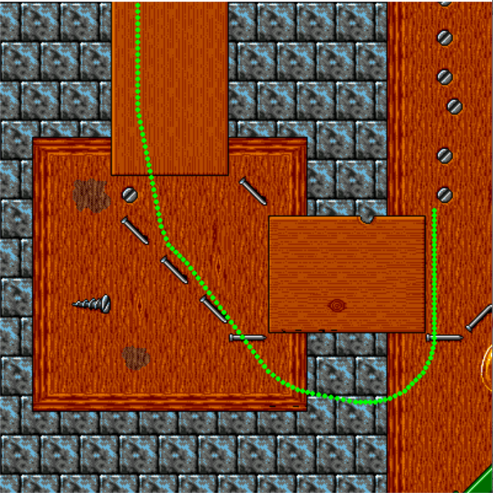

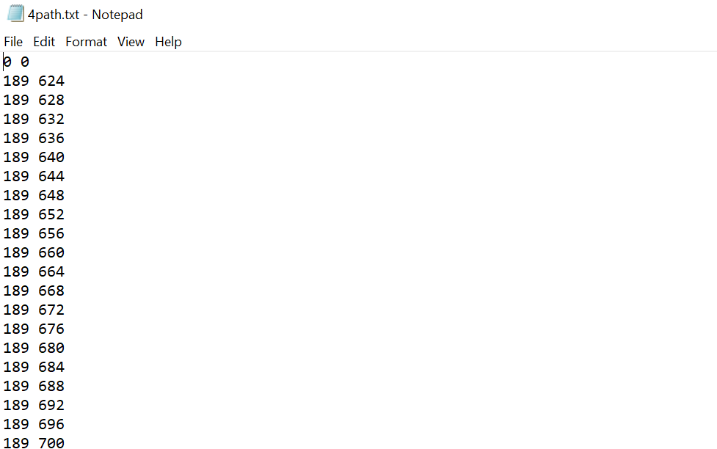This project allows to create paths by putting various point in a array which will be printed in a file. By file this points are supplied to the main project that drives the opponent car through that points.

1. In order to make collision another project is created. This project creates a 2d grid where co- ordinates of place of collisions are marked. Here bitwise operators are used.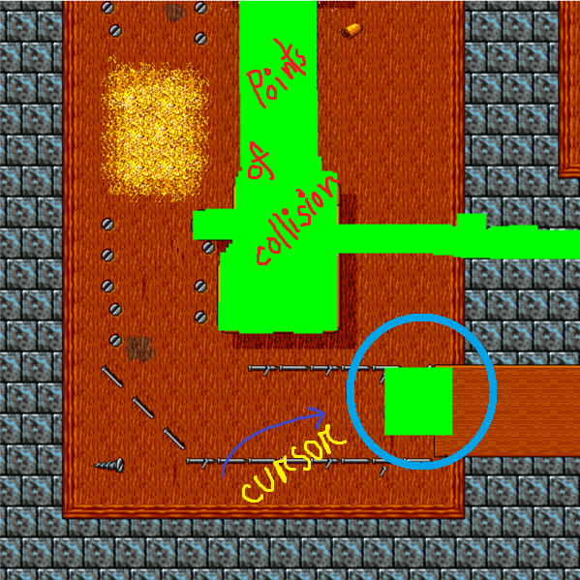In the image the green square which is circled is cursor used to indicate points of collision. The size of the square can be controlled. And the points of collision which are indicated by the cursor are saved in a file.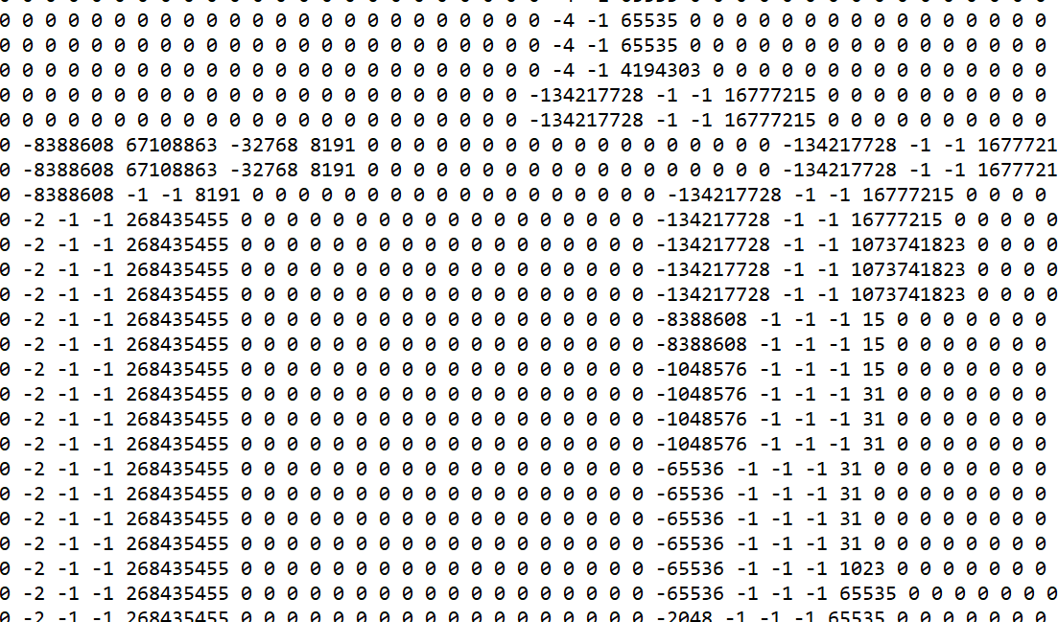This file supply the co-ordinates of the points of collision to the main project that makes an effect of collision in that points.